FUYL Door Replacement Doc
1.The Number Windows are removed by undoing the 3 screws on the inside of the Door. Install the new number window in the same location. Ensure the replacement Number Window matches the number sequence on the FUYL Tower.

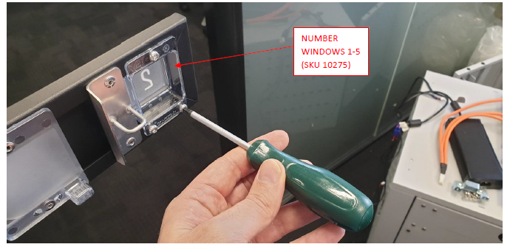
2. Then Remove 3 screws connecting the Door to the hinge
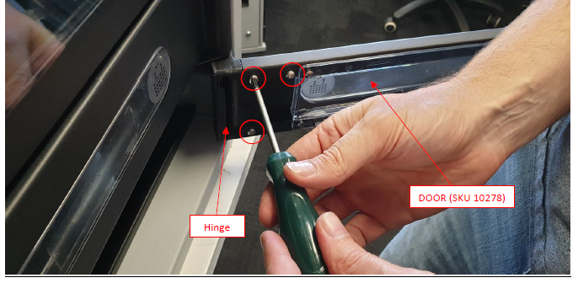

3. Separate Door from hinge by sliding the Door away from the hinge.
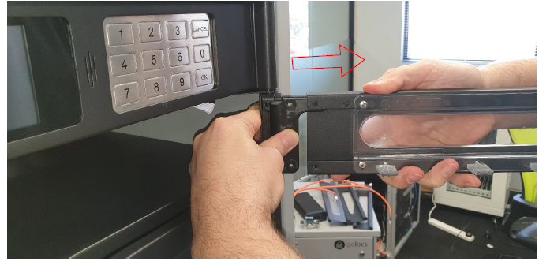

4.
Remove the hinge from the pin. Note the spring will remain in place.
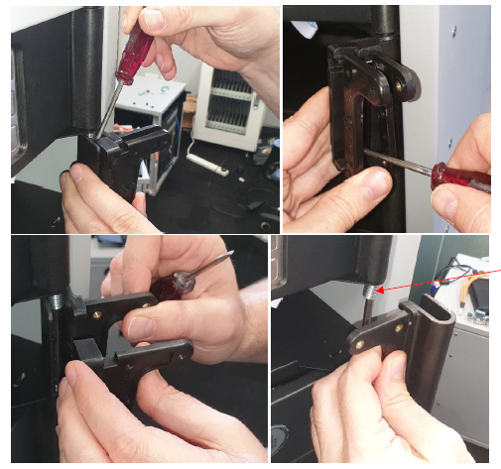
5.
Remove hinge from replacement Door and separate the two hinge parts.
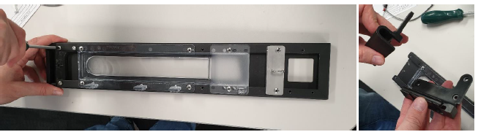

6.
Install female half of hinge around pin and spring.
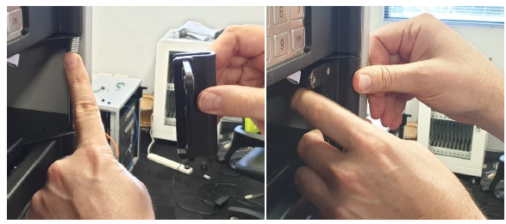
7.
Rotate female half around the pin keeping the spring nested inside the hinge and press the male half of the hinge into the female half.
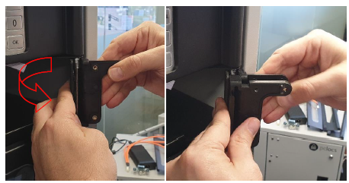
8.
Firmly press the two halves together and slide the replacement Door over the hinges arm.

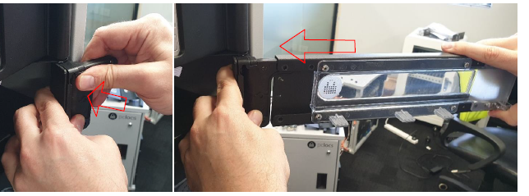

9.
Replace the screws connecting the hinge and Door.
